***Business Reason***

Sales agents want the ability to deal with documentation on a finalized quote.

***Task Requirements***

* When a Quote is in the Finalized step, make the Documents section of the Generate Documents view visiblecsaMarketingCollateral1_quote

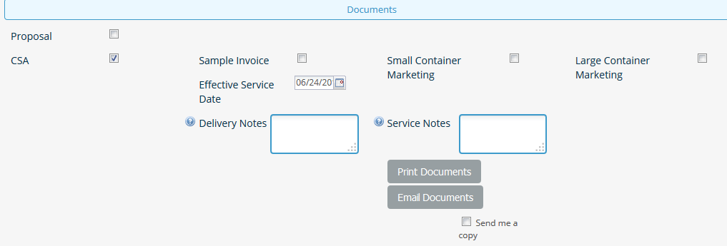

* Read-Only: Effective Service Date, Delivery Notes, Service Notes
* Read-Write: Proposal, CSA, Sample Invoice, Small Container Marketing, Large Container Marketing, Send me a copy
* Action Actions: Print Documents, Email Documents
* Confirm what attributes are updated on those actions, made need to make modifications

***Build Plan***

* Make the following attributes/section visible in the Contract Finalized Step:
  + You go to the attributes themselves and then modify the document views tab.
  + Read-Only
    - proposalHTML_quote, effectiveServiceDate_quote, deliveryNotes_quote, serviceNotes_quote, exemption code, customer rate testriction, year #1, year #2, Year #3, %cpf
  + Read/Write
    - chooseProposal_quote, chooseCSA_quote, includeSampleInvoice_quote, csaMarketingCollateral1_quote, csaMarketingCollateral2_quote, copyEmailSender_quote, includeCoverLetter_quote, proposalMarketingCollateral1_quote, proposalMarketingCollateral2_quote
  + Actions Available
    - Print Documents, Email Documents
    - Confirm what these actions do. If they modify actions, we will need to analyze that.
  + Add new quote level attribute called step_quote
  + Change the page conditions in doc engine so that pages print even if the quote is finalized as long as we are in the contractFinalized step

Generate Document ex. A145270

* Deploy Commerce
* Unit Test
* Comments:
  + When a quote is finalized, we only see the CSA Items and CSA Rear Terms pages. We do NOT see the Cover Page, Proposal Line Items, Small Container Mkt Collateral, Large container mkt collateral, Change ownership CSA, or Invoice Sample. Do we want to change the conditions on these pages so that they show when a quote is finalized?
  + Delivery and Service Notes help icons not working in dev
  + For Anitha,
    - Why do we have the following pages in the CSA document and can we delete them?
      * Backup Proposal Line Items 90
      * Copy of CSA Items
      * Copy of Invoice Sample683
      * Backup Copy of Invoice Sample 72
      * O417 Invoice Sample
      * New Page 973
    - Why do we have so many document copies in doc engine? Which ones can we delete?

***Admin Guide Changes***

***User Guide Changes***